**Department of Computing**

**Hong Kong Polytechnic University**

**Comp 4342 Mobile Computing**

**Project Report**

**Student Name(s):** Pang Chin Wing Student ID(s):18030027D

**Student Name(s):** Wong Ming Yuen Student ID(s):20035673D

**Student Name(s):** Lee Shiu Hin Student ID(s):20071819D

**Student Name(s):** Tsang Yuk Kuen Student ID(s):20035093D

**Student Name(s):** Luis David Geske Student ID(s):20112184X

**Project Title:** Mobile Shopping for computer product

**Abstract**

This project is going to build a mobile application which sells the computer product, this application sells both software and hardware. The application allows users to search for products they wanted and add them to the shopping cart, then check out. Also, they can check the order information such as the order status.

In this project, we want to build a server and a mobile application to Complete an online shopping platform.

In the report, the functionality and implementation of the mobile application will be illustrated. Such as the software architecture, the functions in the application and the design of the client side and server side. Besides, the detailed design about the application logic and functionalities, user manual and a package of source code and installation guide will be included.

**Table of Content**

**1. System Structure & Components 3**

**2. Functionalities 4**

**2.1 Home Page 4**

**2.2 Shopping Cart Page 7**

**2.3 Order page 9**

**3. Class Diagram 10**

**4. Database Tables 11**

**5. Programming Languages and tools used 13**

**6. Testing Strategies and Results 14**

**7. User Manual 16**

**8. Contribution 20**

# **System Structure & Components**

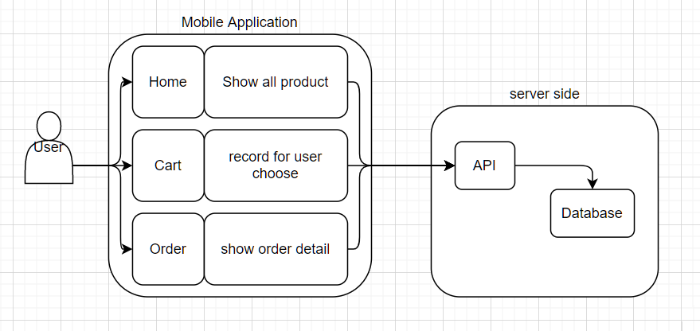

**Mobile Application side**

In this mobile shopping application, there are three main components to build up the application, including the Home page, Shopping cart page and order page.

On the Home page, the application connects the server and requests product information from the server. Then, the product information will be stored in the mobile database as SharedPreferences. Thus, the application allows users to see the product information offline.

On the Shopping cart page, we store users’ selected products in local (the simulator). When users enter their email and click the “ORDER” button, then the order detail with the user's email address will be sent to the server-side and stored in the “order” and “order detail” table. Then, the server will give a response that includes a success or not message and a 6 digits confirmation code generated randomly to the application. Finally, if the order creation is successful, then the application will display the confirmation code and email address for users, otherwise, the application will display an error message.

On the order page, we enable users to check their orders with their email and confirmation code. After they enter their email and confirmation code, we will send it back to the server and see if the provided information matches the data in the “order” table. If so, we will provide order detail to users.

**Server side**

In this project, we use XAMPP phpMyAdmin as our database. XAMPP is one of the widely used cross-platform web servers. XAMPP also contains Apache, MariaDB, PHP and Perl that help us to create and test our application on a local webserver. We implemented PHP files to handle requests from the client-side such as product list, product detail, order detail and so on. We used the JSON format to transfer information between server-side and client-side. It is a popular syntax for storing and exchanging data.

# **Functionalities**

## **2.1 Home Page**

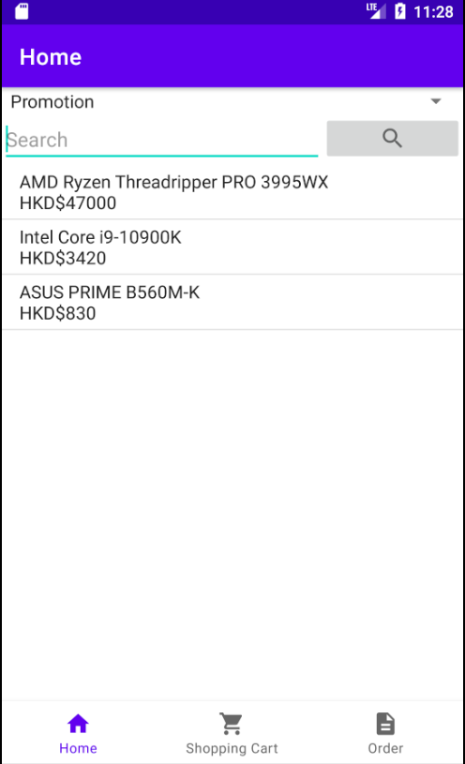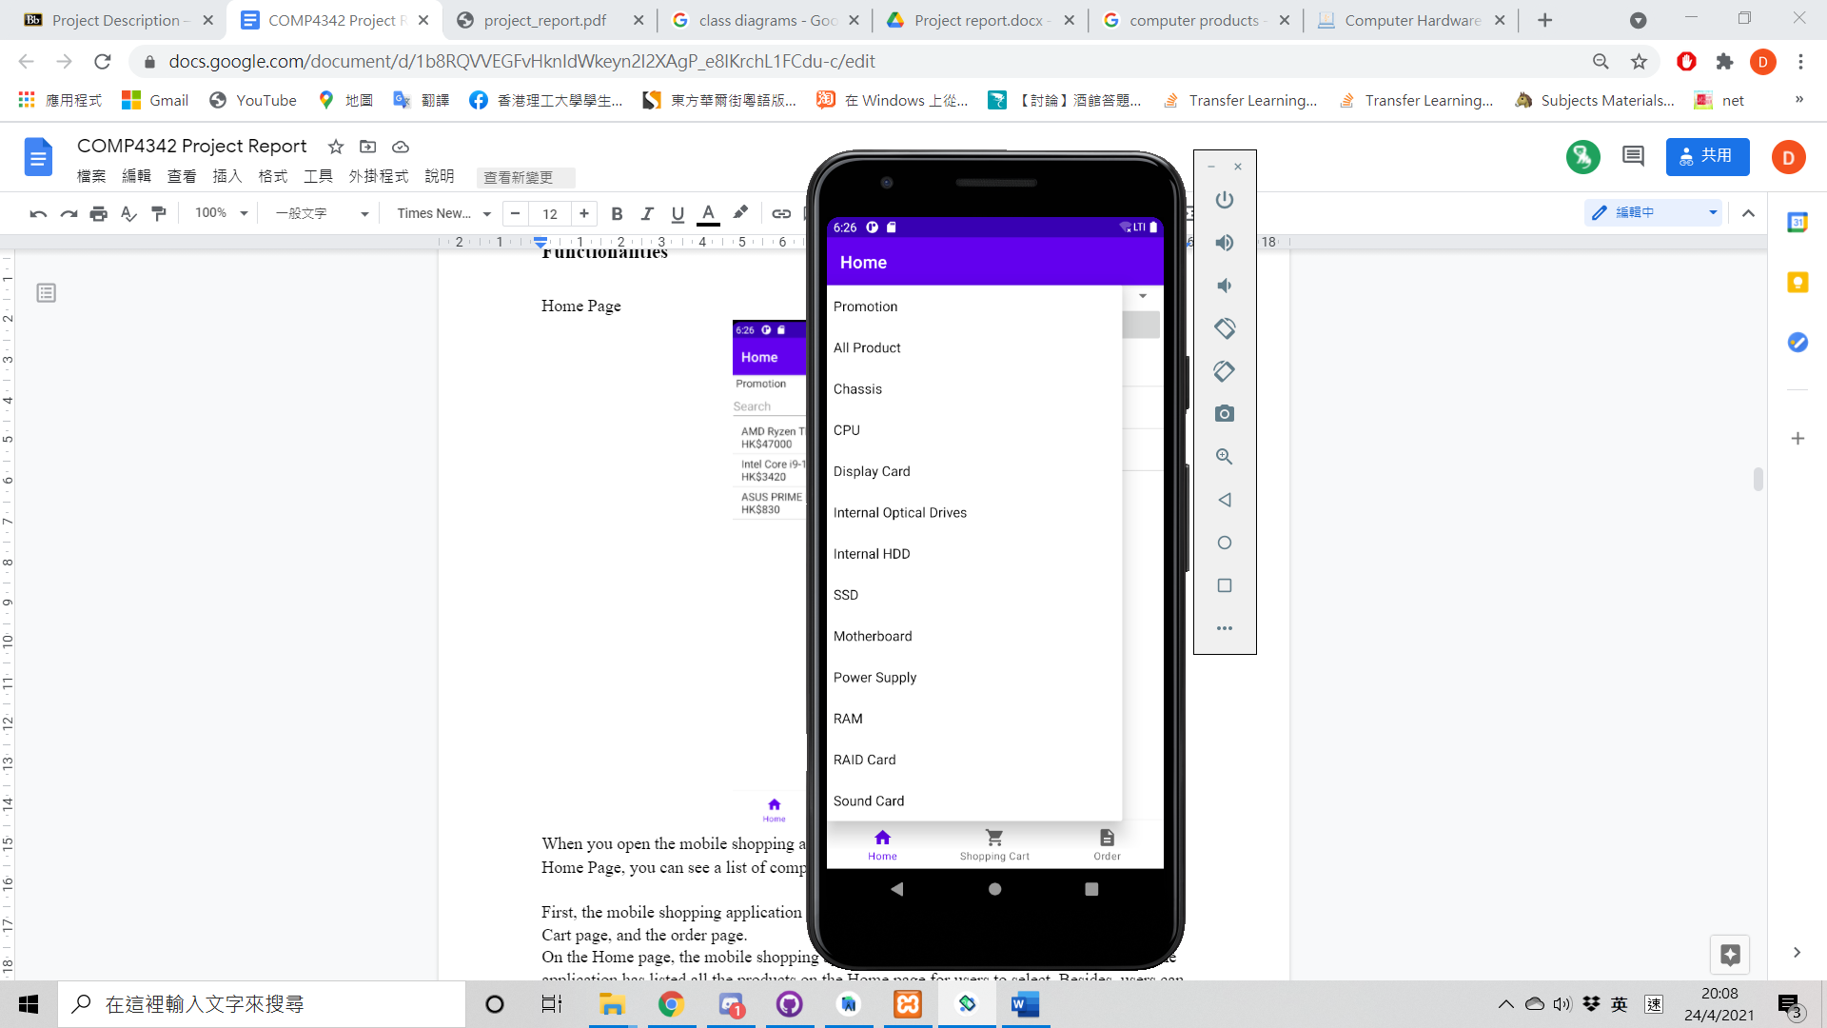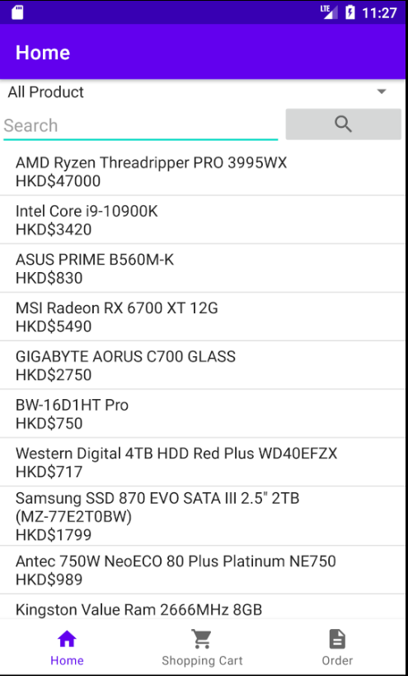

When users open the mobile shopping application, they will see the Home page first. On the Home Page, users can see a list of computer products. The Home Page will display the promotional products in default. The Home page provides a **drop-down list** with categories. Users can click any of them to see what products in the mobile shopping application.

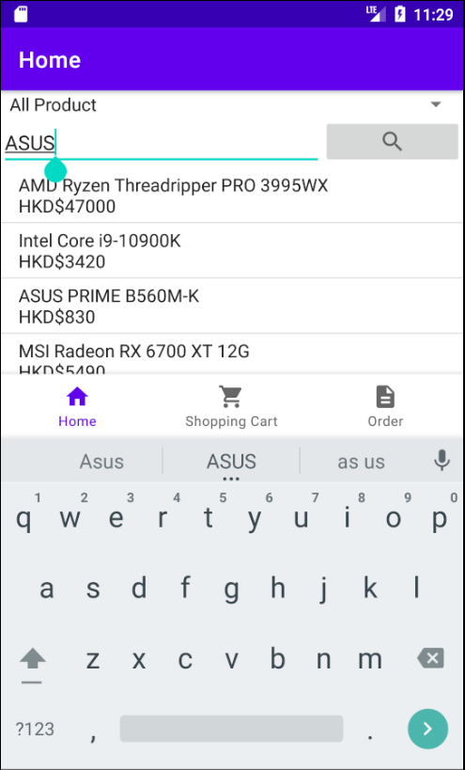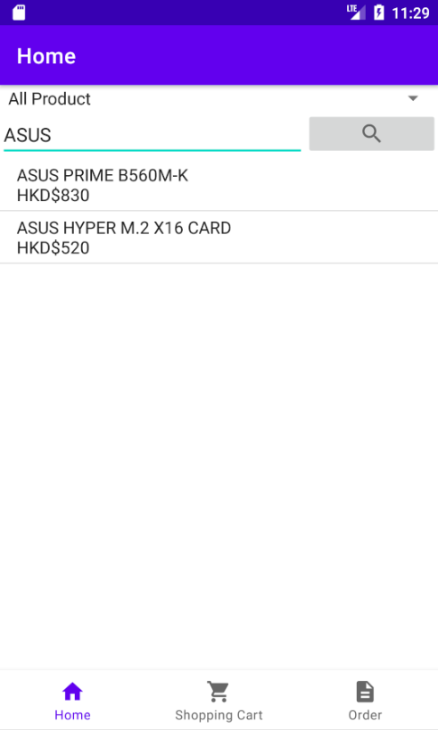

The Home page also provides **a search function** that users can type the keyword to search the specific products. For example, type “ASUS” and click the search icon to display all ASUS computer products.

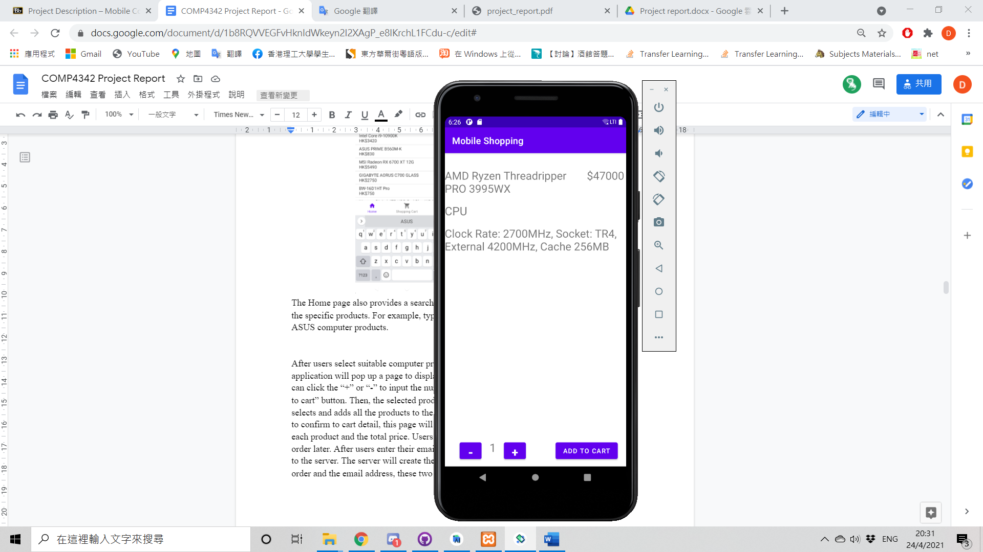

After users select suitable computer products, they can then click the product name. The application will pop up a page to display the details of the product. On the popup page, users can click the “+” or “-” to input the number of products they want to buy, and click the “ADD TO CART” button. Then, the selected products will be placed in the shopping cart and a toast will be shown to the user.

## **2.2 Shopping Cart Page**

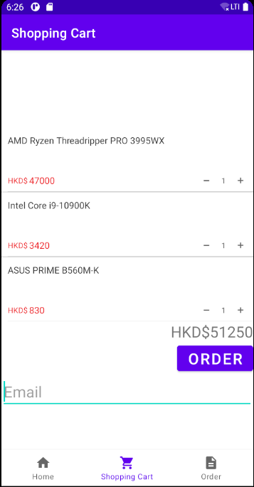

After users select and add products to the shopping cart, they can go to the “shopping cart” page by clicking the bottom navigation bar. In the Shopping Cart, the page will show the product name , quantity of products, price of each product and the total price. On this page, users can still change the quantity of products. If the quantity is equal to the stone, the user will not be allowed to buy more. If the user changes the quantity to zero, the product will be deleted in the shopping cart.

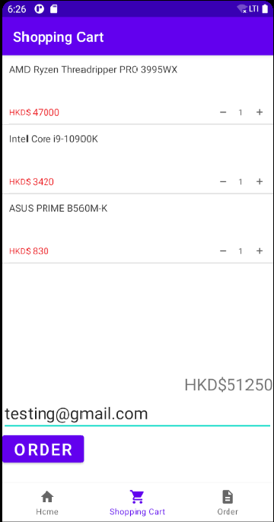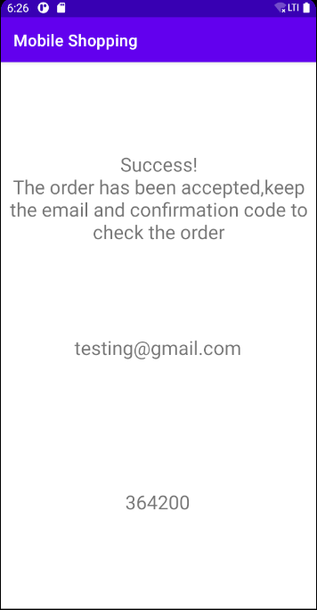

To place the order, users are required to enter their email addresses. It is used to check the order later. After users enter their email addresses, they can click the “ORDER” button to send the order to the server. The server will then create the order and then send back the confirmation code of the order (6-digits) and the email address, these two pieces of information are used to check the order later.

## **2.3 Order page**

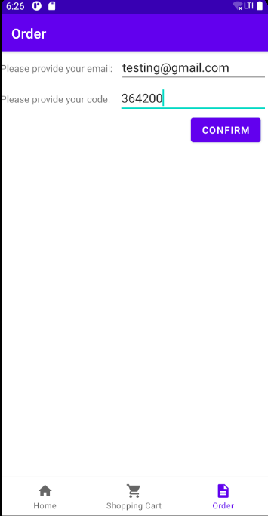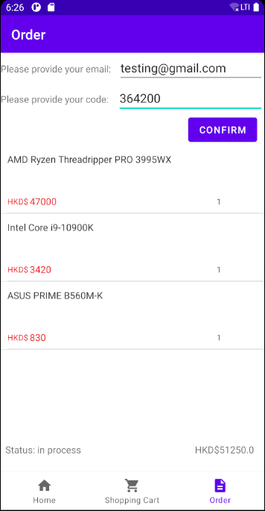

After the user places an order on the shopping cart page, they will receive a six digits confirmation code in the provided email. On the order page, users can input the email address and the 6-digits confirmation code. When the user clicks the “ CONFIRM" button, the database will select the order detail according to the email and confirmation code. If both data are correct, the order page will display the order detail, including the product name, the quantity of the products, the unit price of the product, the total price of the order and the order status.

# **Class Diagram**

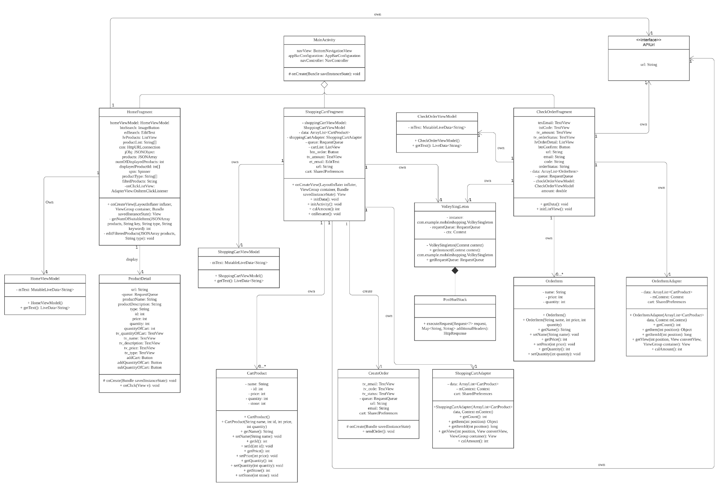

# 

# **Database Tables**

In this project, we have utilized MariaDB Module in XAMPP to create a database.

Below is the structure of the database table:

**Product table**

|  |  |
| --- | --- |
| Field | Description |
| ProductID | To give a unique number for identifying all computer products |
| type | The categories of computer products (e.g. Motherboard, CPU, display card, etc.) |
| brand | The brand of computer products (e.g. AMD, Intel, MSI, etc.) |
| productName | The full name of the computer product |
| productDescrption | The detail of the computer product (e.g. CPU clock rate, number of sockets) |
| price | The price of the computer product |
| quantity | The stock amount of each computer product |
| promotion | Any promotion for the product (1 for yes, 0 for no) |

**Orderdetail table**

|  |  |
| --- | --- |
| Field | Description |
| orderID | To give a unique number for identifying each order |
| productID | To identify which product users have selected |
| quantity | Amounts that users purchase the computer product |

**Order table**

|  |  |
| --- | --- |
| Field | Description |
| orderID | To give a unique number for identifying each order |
| confirmationCode | To identify users & used for checking order detail |
| email | To identify users & used for checking order detail |
| address | To identify users & used for checking order detail |
| status | To represent the status of the order (In process, In delivery, Completed) |

# **Programming Languages and tools used**

In this project, JAVA is the main programming language we used to develop the mobile shopping application. PHP is also used to develop the server side and MariaDB is used to manage the database server.

Below are the tools that we used to develop the mobile shopping application for computer products.

|  |  |  |
| --- | --- | --- |
| Name of Software | Version | Description |
| Android Studio | 4.1.2 | The integrated development environment for developing the mobile shopping application |
| Volley | 1.1.1 | Volley is an HTTP library that makes networking for Android apps easier and most importantly, faster. |
| XAMPP | 8.0.2 | A cross-platform web server with a database |

In this application, the Android version we use is Android 7.0 (Android Nougat). We choose Android 7.0 because it is a relatively new version and 73.7% of the device can run the application.

# **Testing Strategies and Results**

For the testing, we test the program via a set of sample data and test cases created by us. If the program can provide expected results without any error, the program was implemented and suited the requirements as well.

|  |  |  |
| --- | --- | --- |
| Function | Process | Result |
| Display products | 1. open the application on an available network | recommended products are displayed on the home page |
| Display products | 1. open the application on an unavailable network | if the application was opened on an available network before, recommended products are displayed on the home page. if not, there is nothing on the home page. |
| Filter displayed products | 1. select a product type in the spinner which is a drop-down list on the home page | products suited the selected product type are displayed |
| Search products | 1. enter a keyword into the text box on the home page 2. click the search button | products suited the selected product type and contained the keyword in its name are displayed |
| Display product detail | 1. click a product on the homepage in the situation which the network is available | a new page is switched where it displays the product detail. |
| Display product detail | 1. click a product on the home page in the situation which the network is unavailable | a new page is switched where it displays nothing. |
| Add product to shopping cart | 1. click add or subtract button on the page of product detail to change the quantity with the limitation that the maximum number is the available stock on hand and the minimum number is one 2. click “add to cart” button | the selected product and its quantity is added to the shopping cart |
| Change quantity of products on shopping cart | 1. click add or subtract button on the page of the shopping cart to change the quantity with the limitation that the maximum number is the available stock on hand and the minimum number is one | the quantity of the product is changed |
| Make order | 1. enter the email address on the page of the shopping cart 2. click order button | application display a successful message, entered email address and a confirmation code if the shopping cart has some products |
| Make order (exception) | 1. enter the email address on the page of the shopping cart 2. click order button | an error message is thrown if the shopping cart has nothing |
| Review order detail | 1. enter email address and confirmation code on the order page 2. click confirm button | application display the order detail |
| Review order detail (exception) | 1. enter email address and confirmation code on the order page 2. click confirm button | application display an error message if either email address or confirmation code is incorrect |

# **7. User Manual**

This part demonstrates how to purchase computer products by using our mobile shopping application.

1. Click the drop-down list at the top and select any categories. You can also use a search function to search for suitable products.

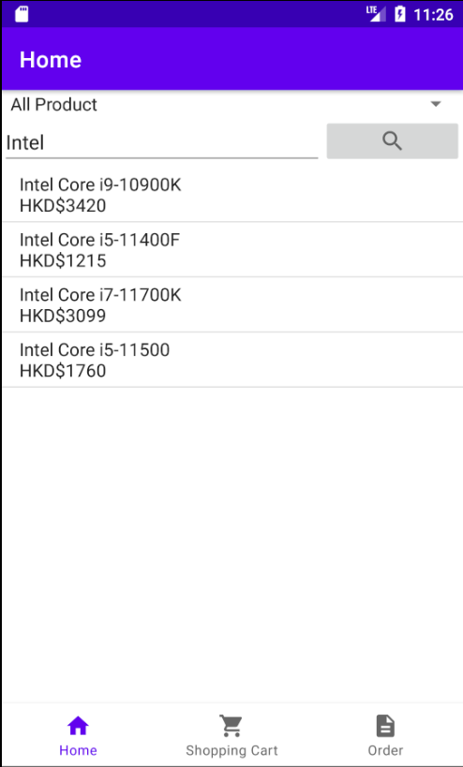

1. Click any of the products to see the product details. You can use “-” and “+” to choose how many products you want to buy. Then, you can click the “ADD TO CART” button and place the product into the shopping cart.

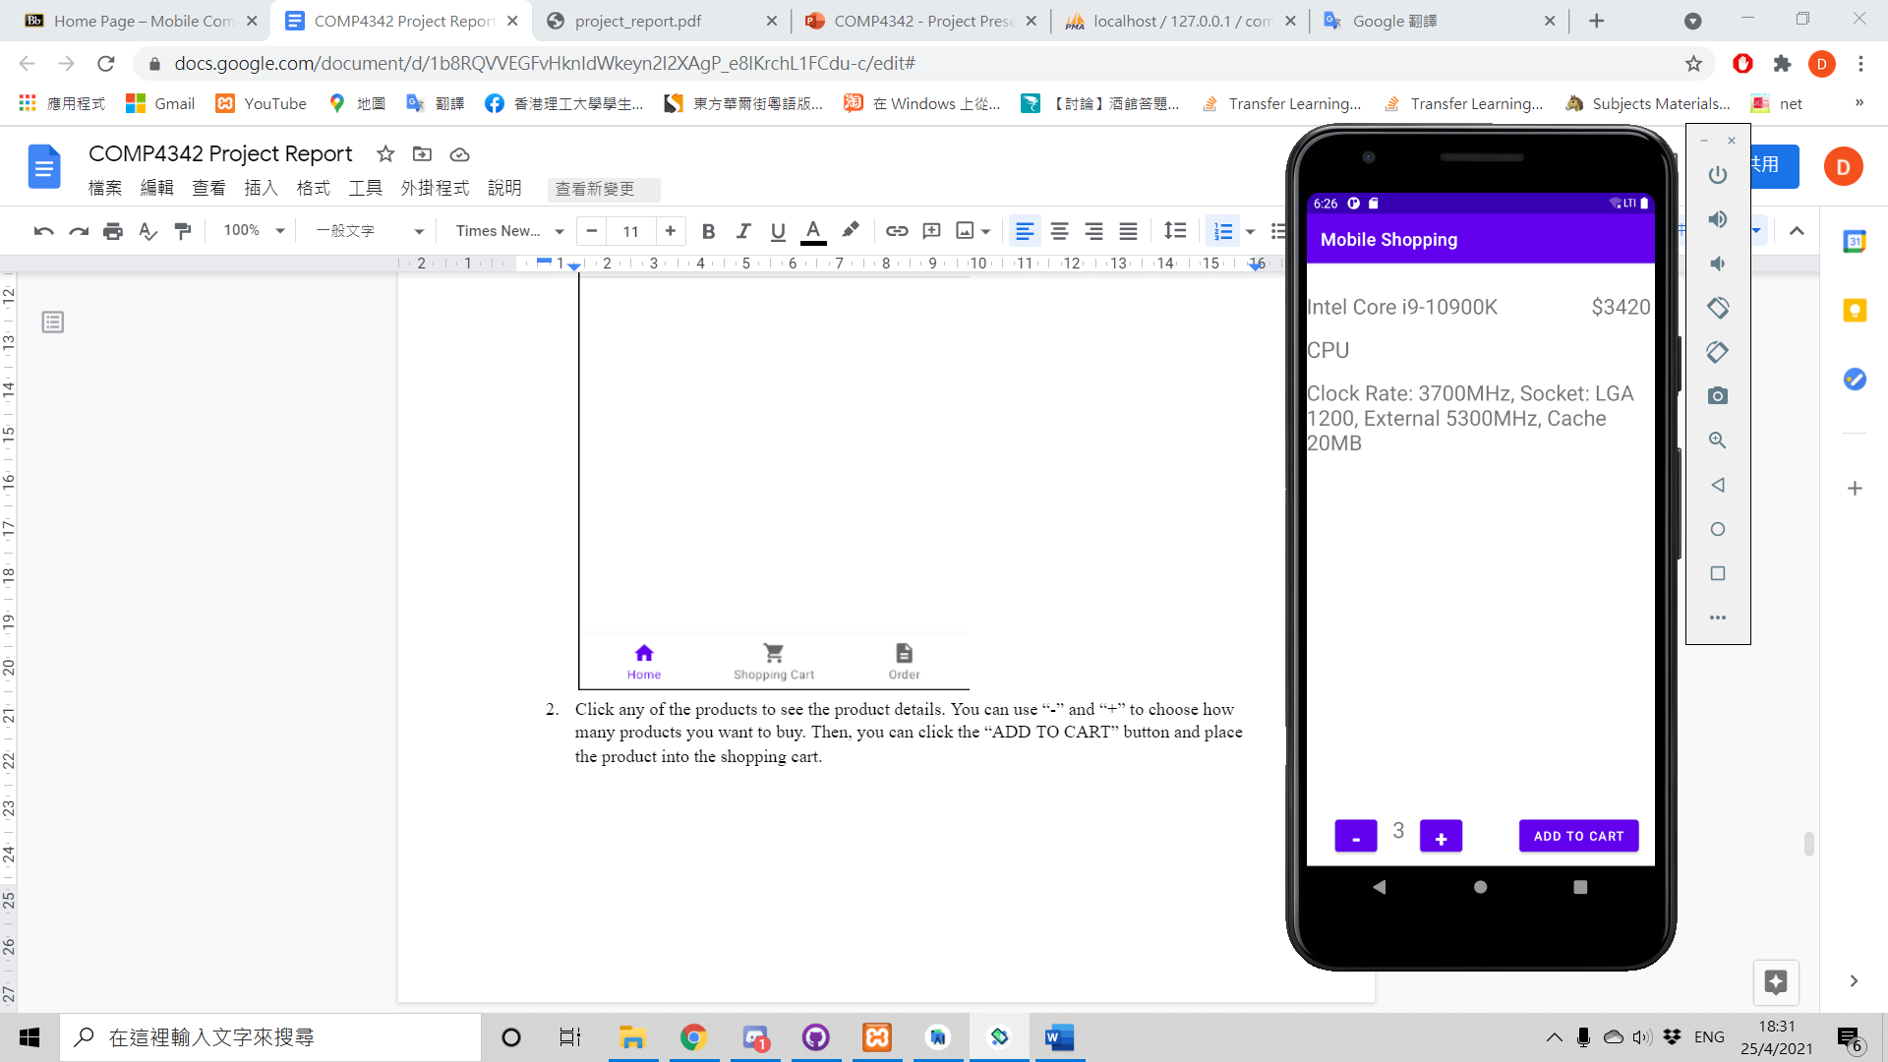

1. Click the Shopping Cart at the bottom to see what we have selected. To place an order, we need to enter email and click the “ORDER” button. In this stage, we already place an order.

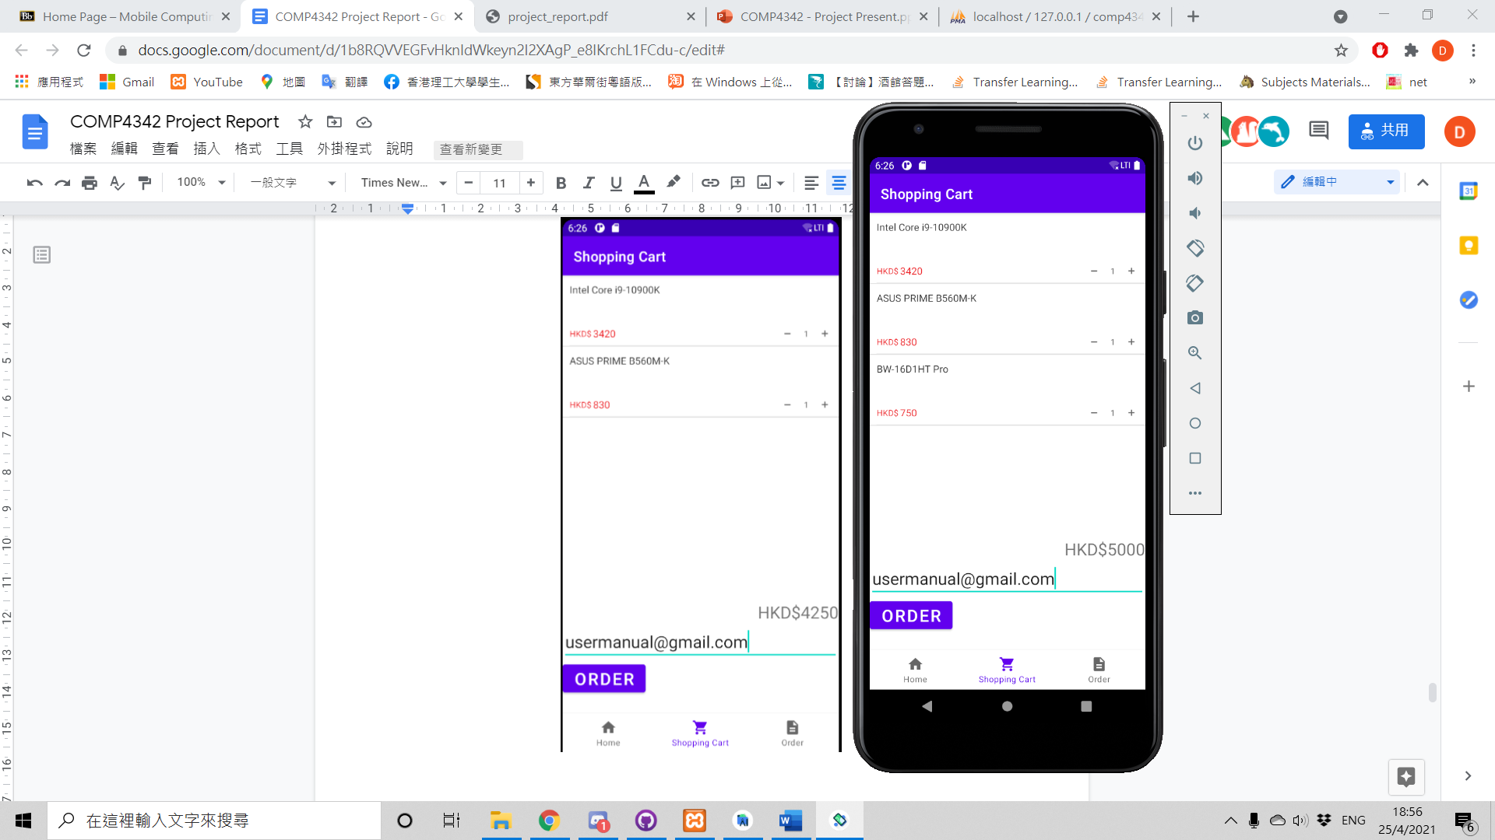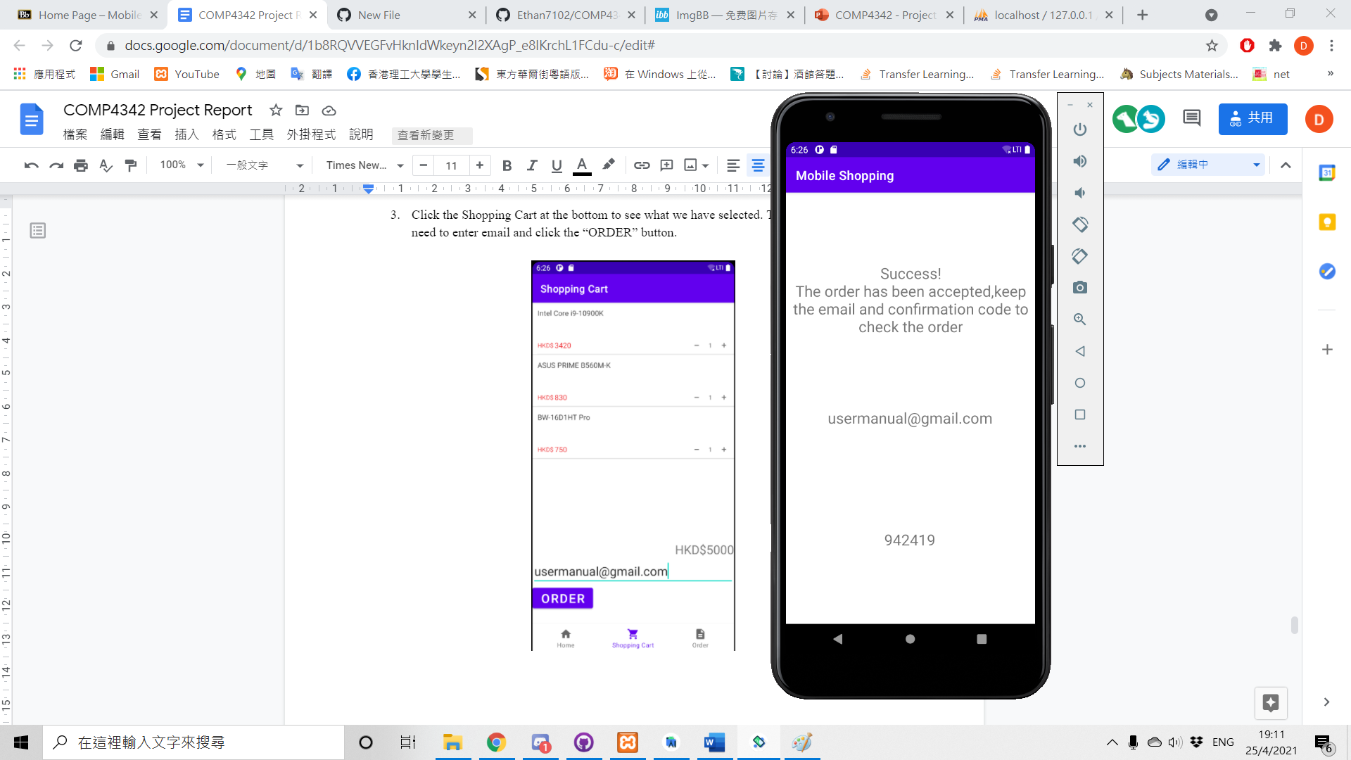

1. In order page, we can also enter the email and confirmation code to check the order

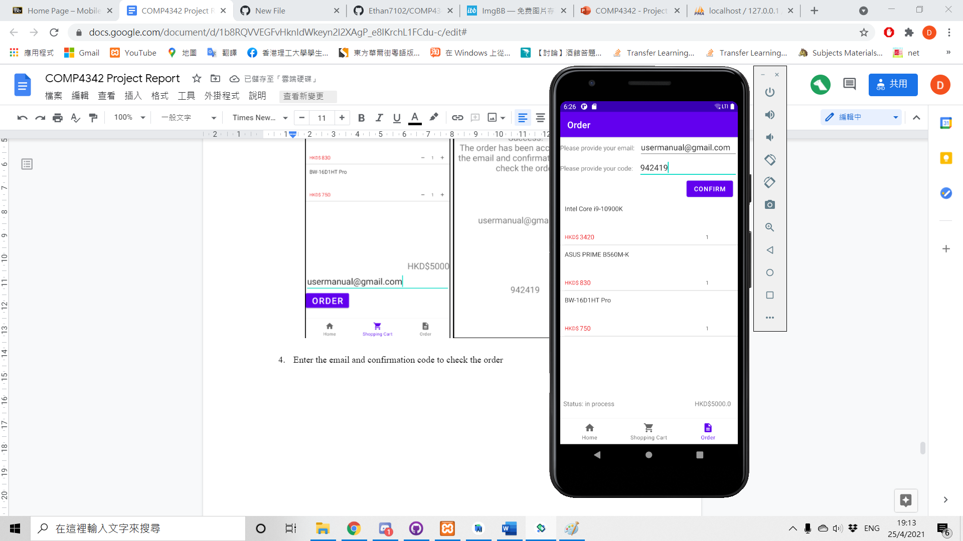

# 

# 8. Contribution

|  |  |  |  |  |
| --- | --- | --- | --- | --- |
| Name | Student ID | Role | Work | percentage of contribution |
| Pang Chin Wing | 18030027D | UI designer | order page (check order detail) | 10% |
| Wong Ming Yuen | 20035673D | programmer, UI designer | home page(display product, search product, filtering product),  order page (check order detail),  report(class diagrams, testing strategies and results, system structure & component) | 30% |
| Lee Shiu Hin | 20071819D | programmer, UI designer | home page(display product detail), order page (check order detail), Shopping cart page(check cart product, send order)  report(System Structure & Components, Functionalities) | 30% |
| Tsang Yuk Kuen | 20035093D | programmer, UI designer | Shopping cart page,  report(user manual,  functionality,  system structure & component,  database tables, programming languages and tools used), presentation recording | 30% |
| Luis David Geske | 20112184X |  |  | 0% |